Name: Prasad Adhiyaman

SPIRE id: 34008503

COMPSCI 528: Mobile and Ubiquitous Computing

Assignment 2

2 e)

Gesture: DOWN ID: 4

From the Gyro raw data, we could see that Gyro Z signal has a lower signal and a lower frequency compared to Gyro X and Gyro Y. Thus, in the Spectrogram we could see that there is a feeble line at lower frequencies. At the same time Gyro X and Gyro Y have a stronger signal after 2.5 seconds which corresponds to the massive shift in the Gyro data. If we look through the raw acceleration data, Acce X has a strong signal at lower frequencies which is displayed sparsely. However Acce Y has a strong low frequency signal until 2 secs. Whereas Acce Z has a strong low frequency signal throughout the gesture.

Gesture: DOWN ID: 5

Looking through the Raw data Gyro X at the 3secs there is a significant shift which is highlighted in the spectrogram at that point. Gyro Y has a stronger signal and the frequencies are really low thus we could see that from 1.5 secs to 3 secs is highlighted in the Spectrogram. Gyro Z has a low frequency string signal after 3 secs which is highlighted in the spectrogram. Acce X has a lower signal entirely thus there is not much being highlighted in the spectrogram, Acce Y has a stronger signal across all frequencies thus the entire spectrogram is highlighted. Acce z has a weaker signal and there is a string signal at 3 secs which is highlighted by the spectrogram.

Gesture: LEFT ID: 10

Looking at the raw data we could see that Gyro X has a stronger signal low frequency until 2 secs which is highlighted in the spectrogram. Gyro Y has a lower signal low frequency until 3 secs and a higher signal after that which is highlighted by a feeble patch. Gyro Z has a lower signal low frequency until 3 secs and drops in the graph which is highlighted in the spectrogram. Acce X is pretty constant until 3 secs but there is some low frequency acceleration after 3 secs which is displayed in the spectrogram. Acce Y has a strong signal with higher frequency which is highlighted in spectrogram entirely. Similar to Acce X, Acce Z is pretty constant until 3 secs but there is some low frequency acceleration after 3 secs which is displayed in the spectrogram.

Gesture: LEFT ID: 12

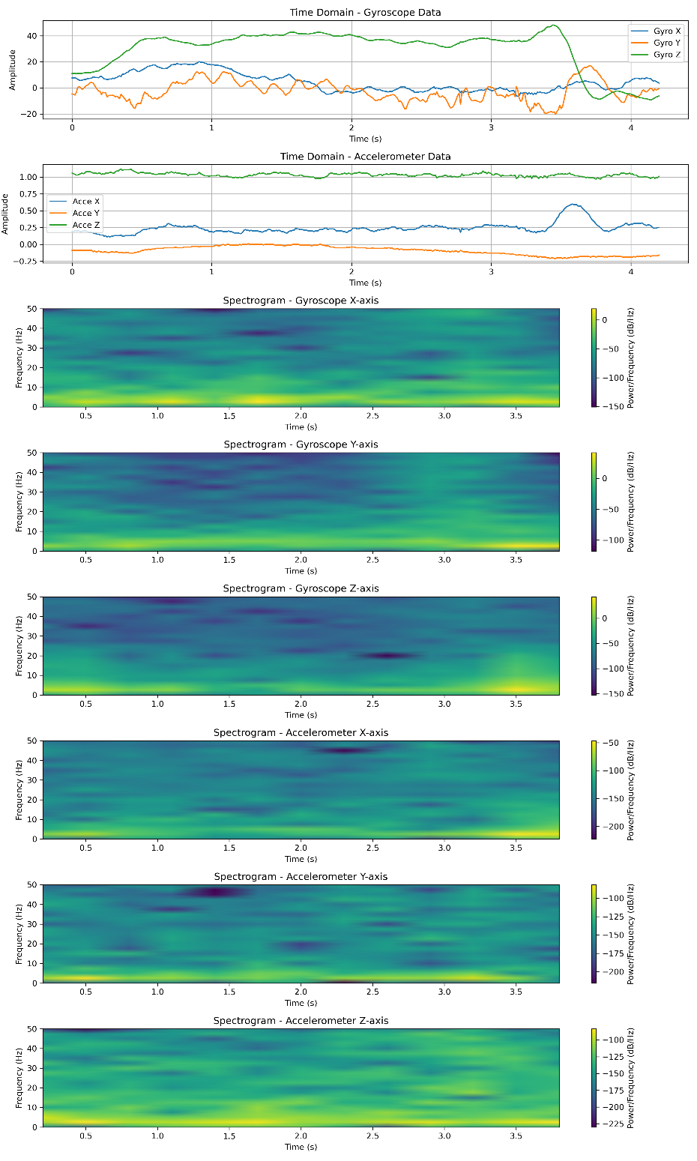

Looking at the raw data we could see that Gyro X has some low frequency strong signals from 1 sec to 2 sec and after 3 sec which is highlighted in the spectrogram. Gyro Y has low signal low frequency signals until 3 secs after that it has a strong signal at a lower frequency as shown in the spectrogram. Gyro Z has a slightly strong signal until 1 sec and after 3 secs which is highlighted in the spectrogram. Acce X has a constant low signal until 3 secs after that there is a strong signal in low frequency. Acce Y has some strong frequency before 1 sec and after 3 secs which is highlighted in the spectrogram. Acce Z has a slightly stronger signal at low frequency through out which is highlighted as a feeble line in the spectrogram.

Gesture: RIGHT ID: 15

Gyro X, Gyro Y, Gyro Z, Acce X, Acce Y, Acce Z has a low signal until 3 secs after that there is a high signal at a lower frequency. In every spectrogram there is a highlight at the lower frequencies after 3 secs.

Gesture: RIGHT ID: 16

Gyro x has a lower signal until 3 secs after that it grows which is highlighted in the spectrogram after 3 secs in lower frequencies. Gyro Y has a higher signal before 1 sec grows at a constant rate and drops after 3 secs which is confirmed by the spectrogram based on the corresponding highlights at the mentioned timeframes at low frequencies. Gyro Z is constant until 3 secs after that is grows which is highlighted in the low frequency domain. Acce X, Y, Z has some high signal low frequencies at 1 sec and is constant until 3 secs after that there is strong signal at a lower frequency.

Gesture: UP ID: 1

Gyro X starts high at 1 sec slowly reduces and goes through a lot of fluctuations after 3 secs which is highlighted in the spectrogram which has both lower frequencies and higher frequencies. Gyro Y follows a similar trend to Gyro X after 3 secs there is both lower frequencies and higher frequencies. Gyro Z is constant for 3 secs and after that it goes through fluctuations which are highlighted in the spectrogram as lower frequencies. Acce X and Acce Z is pretty constant before 3 secs after that there is a slight drop which is highlighted in the spectrogram as low frequencies and some higher frequencies. Acce Y has a sudden drop before 1 sec and a constant growth until 3 secs and sudden drop after that, this is highlighted in the spectrogram as strong signal lower frequencies in the mentioned time frames.

Gesture: UP ID: 2

Gyro X starts high at 1 sec slowly reduces and goes through a lot of fluctuations after 3 secs which is highlighted in the spectrogram which has strong lower frequencies. Gyro Y follows a similar trend to Gyro X after 3 secs there are strong lower frequencies. Gyro Z is constant for 3 secs and after that it goes through fluctuations which are highlighted in the spectrogram as lower frequencies. Acce X and Acce Z is pretty constant before 3 secs after that there is a slight drop which is highlighted in the spectrogram as low frequencies and some higher frequencies. Acce X might have a lot of higher frequencies causing the entire spectrogram to be highlighted. Acce Y has a sudden drop before 1 sec and a constant growth until 3 secs and sudden drop after that, this is highlighted in the spectrogram as strong signal lower frequencies in the mentioned time frames.

Looking at the raw data of accelerometer and gyroscope there is an obvious difference across different gestures and a similarity across the same gestures. This is because there is a significant motion of each axis on the gesture being performed which helps to spot the difference and similarities. Analyzing the raw data and comparing it with the gesture makes it clear on why a particular axis is constant or fluctuating heavily.

Training SVM and KNN on the collected gestures:

To prevent overfitting the dataset was split into training validation and testing sets where training has 15 datapoints per gesture, validation has 2 datapoints per gesture and testing has 3 datapoints per gesture. All the datapoints were flattened and were used to train the SVM and KNN model which is used to predict on the validation and the testing set. The following are the confusion matrix for validation set and the testing set predicted by the SVM model.

Validation set predicted by the SVM model

Testing set predicted by the SVM model

From the confusion matrix it is clear that the model has a good accuracy in categorizing the gestures. Following is the confusion matrix for the validation and testing set predicted by the KNN model.

Confusion matrix for the validation set predicted by KNN

Confusion matrix for the testing set predicted by KNN

From the confusion matrix it is clear that the model is capable of categorizing the gestures with 100% accuracy.